System Administration Parameter N-K-1 OESCREEN

If your customer service or order entry personnel get the order quantity confused with the Sell Price unit of measure, this is your solution.

Set the logical value Yes to display order quantity UOM during order entry
Set the logical value NO to not display the order quantity UOM.

Order entry clerks would like to enter quantity of 1 then UOM = M.
This will convert the quantity from 1 M to 1000 EA.
If they enter 1 M, it will change the order quantity field to 1000.
If they enter 1 EA, it will remain as 1.
If they enter 1 C, then the system would multiply by 100.
If they enter 1 CS, then the system will multiply 1 x the count for new Qty.
If they enter 1 SET, PGK, BDL, EA or ROL then the quantity will will not change.

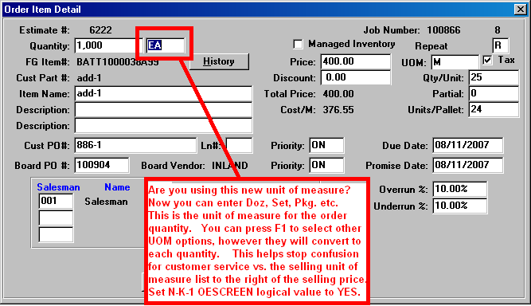

Press F1 for a valid list of order quantity unit of measures.

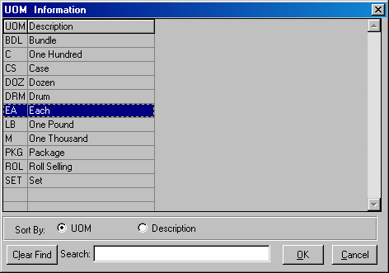

Please note, valid unit of measures may need to be added to the system administration UOM file under N-Z menu.

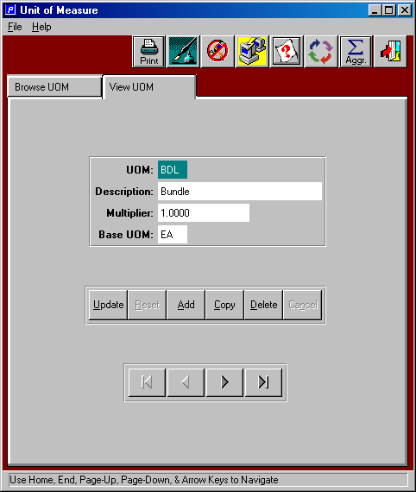

System Control Parameter dictates display of the field.

